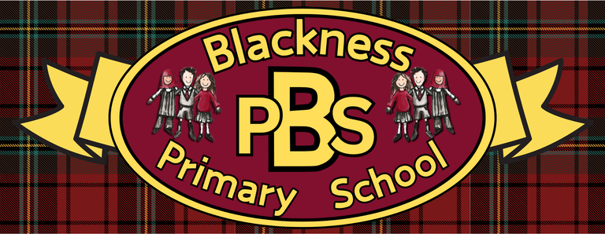 “Everyone Here Matters”
Developing Healthy Choices  Keep a food diary to review the food and drink that you consume each day. Which parts of your diet are the most healthy? | Nutritional Needs  Can you cut out magazine food images and glue them under correct nutrient headers like carbohydrates, proteins, vitamins, and fats? | Keeping safe  Identify 6 possible hazards within your kitchen. Explain why they are a hazard and how harm is prevented. | The journey of food  Kitchen Cupboard World Mapping  Look at 6 different food labels and investigate on a world map where they have come from. Rank them in order from furthest away to nearest.
Food technology  Across the course of a week try to use as many different food preperation tools as possible e.g. grater, whisk, peeler etc). Get a photo of you using each one. | Physical Activity  Do 30 minutes of outdoor activity 3 times a week. Draw a picutre that shows the different sports/activities you took part in. | Social Wellbeing  Make a certificate for a friend to celebrate one of their special qualities or an achievement. | Zones of Regulation  Can you list your top 3 strategies that are effective when you are in the blue, yellow and red zones?
Healthy Relationships  Go to https://wordart.com/  And create a word art picture filled with compliments for someone that means a lot to you! | Mental and Emotional Wellbeing  Go on a ‘senses walk’. Head to a familiar place (or somewhere completely new) and think of all of the things that you can see, hear, smell and feel. | Mindfulness  Put hidden objects inside a bag and someone guess what each item is using only their sense of touch. | UNCRC  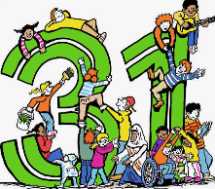  The Right to Play  Design your dream play park. Think about all your favourite things from all the different parks you have been to!

Ready Respectful Safe

Ready Respectful Safe

